 |  |  | Updated: August 30, 2021
The Soundside
Site Rental Information

Type of Renter | Dare County Non-Profit | Dare County For-Profit | Outside of Dare County
Event Site Rental Rate (Per Day) | $600.00 | $1,500.00 | $2,400.00
Set up and Breakdown Days for the Event (per day) | $300.00 | $750.00 | $1,200.00
Electrical Rates: all 220v & 50 amp poles on the site (per day) | $230.00 | $230.00 | $230.00
Electrical Rates: 100 amp box (per day) | $300.00 | $300.00 | $300.00
Wi-Fi at the Event Site: covers the entire length of the event (not per day) | $450.00 | $450.00 | $450.00
* Non-Profit Organizations (Dare County based) must submit proof of 501(c) status to receive above rate.*
** Any Site rental longer than 7 days will be negotiated with Outer Banks Visitors Bureau
Site Damage Deposits (Refundable after post-event walk thru & landscaping test):
Under 500 = $500 per event |  | Over 500 = $1000 per event
Dairy Queen building & 23 parking spaces in front are for event developer use only; not for event goers. Must be reserved in advance.
Pamlico Jack's and South Beach Grill parking lots are also available for off-site event parking, must be reserved in advance and indicated on your application.
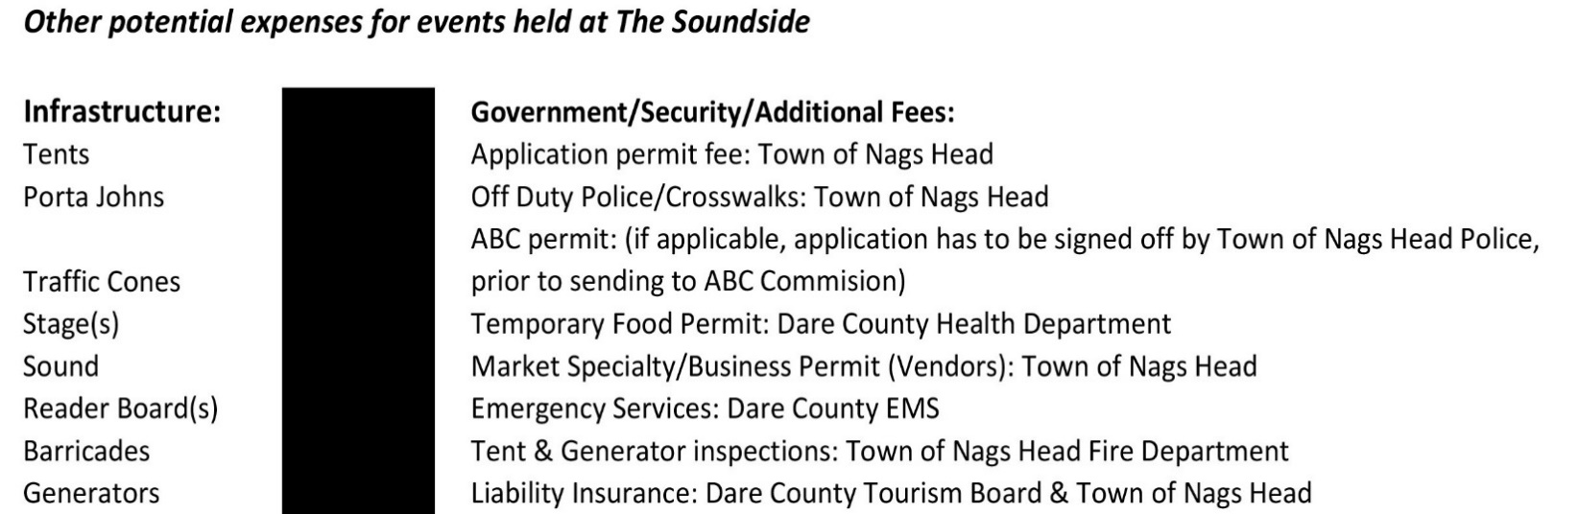

The Soundside | CHECKLIST
Please read all guidelines, policies and rates. All forms are submitted to the Outer Banks Visitors Bureau.
No more than 1 year prior to your event, submit:
- Reservation application form with the $200 reservation fee. Make check payable to Outer Banks Visitors Bureau.

45 Days Prior to the Event, Submit:

- Final event permit form
- Final Site plan
- Final Parking plan
- Signed copy of the release and indemnity agreement for facility use
- Signed copy of the site guidelines, policies and rates
- NC ABC permit (will require ABC lease letter from Outer Banks Visitors Bureau)

30 days Prior to the Event: (All items below must be submitted to Outer Banks Visitors Bureau prior to the Town of Nags Head reviewing the permit application)

- Remainder of the Site rental fee
- Site damage deposit
- Special event permit fee (payable to the Town of Nags Head)
- Town of Nags Head Security Contract, signed and payment due (if applicable)
- Temporary Food Establishment Permit submitted to Dare County Health Department
- Proof of Certificate of Insurance for Public Liability

14 days Prior to the Event, Submit:
- On-site Electricity request
- Final list of vendors and/or concessions and vendor number
- Contact the surrounding businesses around the event site to let them know about your upcoming event (OBVB has company list if needed)
3 Days Prior to the Event:
- Walk through Site with Outer Banks Visitors Bureau and Event Organizer representatives
Day of Event:
- If applicable, inspection fee, due to the Town of Nags Head
- Be sure to have all permits, licenses, etc. on hand at site.
Post Event:
- Walk through Site with Outer Banks Visitors Bureau and Event Organizer representatives
- Submit letter for refund of Site deposit
The Outer Banks Visitors Bureau reserves the right to cancel the site reservation
if deadlines are missed by the Developer.
The Soundside
Outer Banks Event Site
6800 S. Croatan Hwy
Nags Head, NC 27959
Event Application

1. Event Name: Click here to enter name.
Actual Event Dates: Click here to enter event date(s).

Time of Event (per day if applicable): Click here to enter times of your event.

Site Reservation Start & End Dates: Click here to enter dates to reserve event site.
(Include your move-in and move-out dates)

Estimated Total Attendance: Click here to enter the estimated number of people over the course of your event.

Anticipated Peak Attendance: Click here to enter the peak number of people you expect on-site at one time.

2. Name of Non-Profit Organization (if applicable): Click here to enter non-profit Name.

Non-Profit Address: Click here to enter non-profit address.

Non-Profit Email Address: Click here to enter non-profit email address.

Non-Profit Telephone Number: Click here to enter non-profit telephone number.

(If the event organizer is different than the non-profit, please fill out the below):

Event Organizer/Planner Name/Point of Contact: Click here to enter Event Organizer Name.

Event Organizer/Planner Address: Click here to enter Event Organizer Address.

Event Organizer/Planner Email Address: Click here to enter Event Organizer Email.

Event Organizer/Planner Telephone Number: Click here to enter Event Organizer Telephone number.

3. Explain the Type of Event: Click here to enter event description.

4. Name(s), email addresses, and cell/telephone number(s) of designated Crowd Control Manager, Point of Contact and any other representative(s) and responsibilities or titles, who will be responsible for maintaining contact with Town personnel throughout the event.
Click here to enter Crowd Control Information.

5. Provide a full description/schedule of your event each day (can be a tentative event schedule).
Click here to provide your schedule of events.

6. Provide Information on designated parking areas and a traffic flow description on and off the event site. The Site can accommodate up to 1250 total guests with use of all OBVB lots and depending on layout of the event. Capacity is based on the peak attendance at one time during the event. Higher capacity is possible but will require a plan for off-site parking in addition to parking at the Site. If parking off-site, attach a letter from that property owner verifying how many excess parking spaces will be available for the event. (Event Organizers CANNOT use the Harvey Estuarine Site as part of their plans for parking or infrastructure)
Click here to describe your event parking plan.

7. Describe use of parking and event staff or other personnel regarding crowd and traffic control. Please indicate if private security will be on site and if off-duty police officers are needed.
Click here to enter crowd and traffic control plan.

8. What are your plans for emergency medical services and first aid?
Click here to enter emergency services and/or first aid plan.

9. How do you plan to ensure emergency vehicle access at the event?
Click here to enter your plan for emergency vehicle access.

10. How will you broadcast emergency information to your vendors and event attendees, both before and during your event?
Click here to enter your broadcast emergency information.

11. How are you planning to monitor weather conditions and what will be your protocol for a weather-related event cancellation?
Click here to enter your weather monitoring plan

12. If an evacuation of the site is not possible due to an emergency situation (ie: weather), what is your plan to shelter in place?
Click here to enter your shelter in place plan.

13. List and describe all temporary structures. Describe the use of electricity at the site. Town building Inspections will be required for generators and other temporary structures.
Click here to list your temporary structures and use of electricity.

14. Describe your process for collecting recyclables and solid waste. Event organizers/planners are responsible for securing a vendor for trash/recycle collection; the Town of Nags Head does not provide trash collection for events at the Soundside Event Site.
Click here to describe your trash collection plan/provider

15. Are there any special hazards at this event? (example: cooking related fires, environmental emergencies). List them and explain how you are managing these hazards, including a list of relevant safety equipment that will be present at the event.
Click here to enter your plan for special hazards.

16. Sanitary Facilities: List the number and type of facilities that will be provided on site. The restrooms at the Harvey Estuarine Site are NOT available for use during any event held at the Soundside Event Site.
Click here to describe the sanitary facilities.

17. Are you planning to have alcohol consumption during event: ☐ Yes ☐No

☐Beer ☐Wine ☐Liquor NC ALE Permit, attached ☐ Yes ☐No

Describe how alcohol beverages will be served at your event.
Click here to enter your beverage description.

18. List all temporary signs to be displayed during the event. All signs shall be located within the boundaries of the event area and be directed internally. Signage shall be promptly removed once event is concluded.
Click here to list the type of signage at the event.

19. List all vendors and concessions (attach sheet if necessary).
Applicants must purchase a vendor license (also called Specialty Market Permit) prior to operating concessions or provide proof that participating vendors already have a vendor license with Nags Head.
Click here to enter list of vendors.

20. Event Site Plan: Include the following elements on the event map (site template attached to this document):
a. Boundaries of main event area within entire Site
b. Participant activity areas and access points (crowd flow)
c. Number and location of concessions, stages, or other event activity areas
d. Parking locations, estimated capacity and traffic circulation
e. Location of medical services if needed
g. Location and number of trash and recycling receptacles
h. Location and number of sanitary facilities
I. Size and location of tents or canopies
j. Location and number of generators or poles to be rented
k. Please show your emergency exits on your event map

I have read the Soundside Event Site guidelines and completed this application and ensure that our group will comply with regulations, policies and fee schedule governing the use of the event site.
Event Organizer/Planner: Click here to sign

Application Date: Click here to enter date

Local Phone Number: Click here to enter phone number
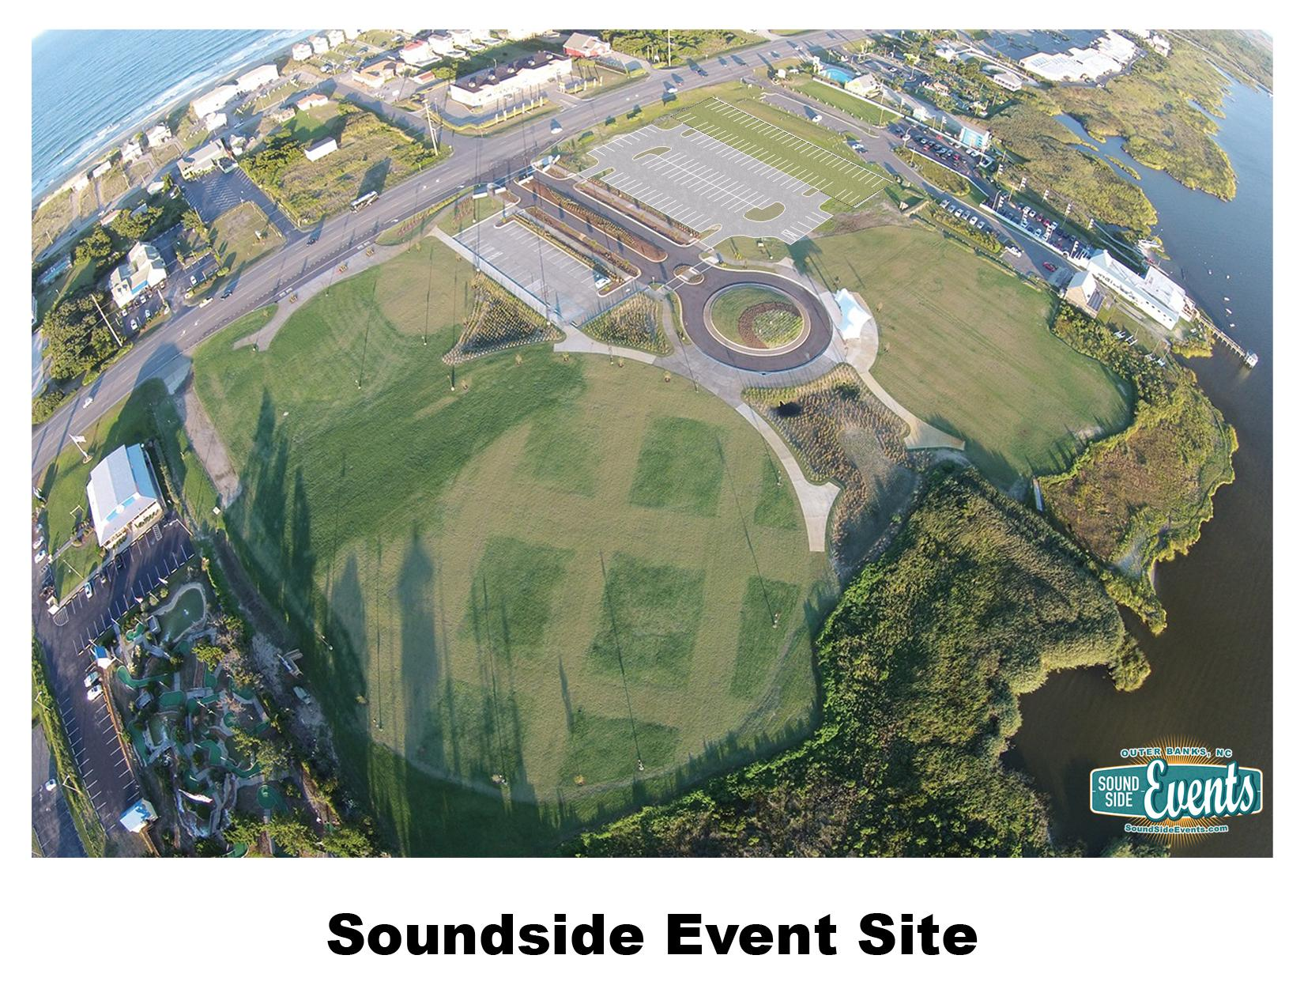

Town of Nags Head – Dare County Tourism Board

(dba Outer Banks Visitors Bureau)

Release and Indemnity Agreement for Facility Use

WHEREAS, the undersigned has requested the use of The Soundside event Site owned or operated by the Town of Nags Head and the Dare County Tourism Board (the “Owners”), located at 6800 S. Croatan Hwy. Nags Head, NC and do engage in activities for the exclusive benefit of the undersigned.

NOW, THEREFORE, In consideration of the mutual promises or other good and valuable consideration, the undersigned does hereby for himself/herself, his/her heirs, executor, employers, successors, of himself/herself or of his/her employees, administrators, and personal representatives, I/We/The Event Organizer),
Click here to enter name. understand and agree to the following:

The Owners shall not be liable for any damage to property or person by reason of the Event Organizers use or occupancy of the Premises and the Event Organizer agrees to save the Owners harmless from and against all claims, suits, demands, actions, and the cost and expense thereof, including attorney’s fees, arising out of any property damage or personal injury occurring as a result of applicant’s use of the Premises. *The Event Organizer further specifically agrees that it will procure and keep in full force at its expenses, Commercial Liability Insurance in an amount not less than $1,000,000.00 per occurrence, which policy or policies of insurance shall show the Owners as additional insured. Event Organizer will cause a certificate of insurance to be furnished to the Owners evidencing such coverage and said policy shall provide that said insurance may not be cancelled without written notice to the Owners at least thirty (30) days prior to any cancellation.

I/We/The (Event Organizer), Click here to enter name.
hereby declare that the terms of this Release and Indemnity Agreement have been fully read and understood by me, and freely and voluntarily entered into and accepted by me, and I hereby acknowledge that I have read and understand this agreement. This agreement shall be in full force and effect any time after the execution thereof.

Print Name: Click here to enter Name. Electronic Signature: Click here to sign.

Date: Click here to enter date.

*If Event Organizer is renting as an individual, the commercial liability insurance is not required. It is understood that the individual’s homeowner’s policy may apply. Please consult with your insurance agent or carrier. This statement does not act as a waiver of any of the other conditions of paragraph 3 cited above. If the individual renter has an organization, commercial entity or other recognized entity providing any assistance or services then that entity or organization is required to carry commercial general liability insurance with the specified limits and is required to provide the Town of Nags Head and Dare County Tourism Board with a certificate of insurance as noted above.

THIS PAGE MUST BE SUBMITTED WITH THE FULL APPLICATION

FOR TOWN USE ONLY
Comments or restrictions imposed by Police, Fire, Zoning, Health Department or Other: Click here to enter all comments or restrictions here.

APPROVED BY: Click here to enter electronic signature.
Outer Banks Visitors Bureau, Executive Director

COMMENTS: Click here to enter comments.

DATE: Click here to enter date.

APPROVED BY:

Planning & Development Director: Click here to enter electronic signature.
Date: Click here to enter date.

Fire Chief: Click here to enter electronic signature.
Date: Click here to enter date.

Police Chief: Click here to enter electronic signature.
Date: Click here to enter date.

Public Works Director: Click here to enter electronic signature.
Date: Click here to enter date.

Town Manager: Click here to enter electronic signature.
Date: Click here to enter date.

The office of the Town Manager, PO Box 99, 5401 S. Croatan Hwy, Nags Head, NC 27959; 252.441.5508

